

NUST COLLEGE OF
ELECTRICAL AND MECHANICAL ENGINEERING

IMPLEMENTATION OF MOBILE PLATFORM
USING COMPUTATIONAL VISION

LITERATURE REVIEW
DE-42 MTS

Submitted by
MUHAMMAD YOUSUF HASNAIN
AZMAT ALI BAKHT
ZAIN BIN SAJID
ABU BAKAR

BACHELORS IN MECHATRONICS ENGINEERING
YEAR 2023

PROJECT SUPERVISOR
Dr. AYESHA ZEB
LITERATURE REVIEW:
- Six DOF Quadrotor Mathematical Model
In recent years, a plethora of hovercrafts have been utilized as UAVs, including fixed-wing airplanes, airships, and helicopters, among others [1]. Nonetheless, the aircraft that have garnered the most attention for remote investigation applications are multirotor copters, specifically quadcopters, the reason being that these aircraft boast various advantages over others. They have a straightforward structural design, excellent flight capacity and maneuverability, especially their capability for vertical take-off and landing (VTOL) and ability to hover [2]. A quadcopter obtains flight through four DC motors, each controlling an identical rotor, which is upward-facing and positioned in a square-shaped arrangement at equal distance from the center of mass of the quadrotor [3]. Each motor’s speed can be controlled independently of the other, permitting balanced alteration of the rotors’ speed, therefore generating thrust and accelerations in the desired directions. This allows quadrotors more stability.

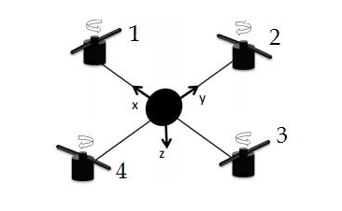
Figure 1: Quadrotor structure [12]
A quadcopter is considered a six-degrees-of-freedom (6-DoF) system, implying that it moves in 6 directions and 6 variables are required to show its altitude and attitude in space (x, y, z, φ, θ and ψ). The variables x, y and z represent the translational motion of the quadcopter. A fixed reference frame is used for this purpose and x, y and z respectively indicate the distance of the copter’s center of mass along x, y and z axes as depicted in Figure 1, from this frame. The remaining three variables are the Euler angles, used to indicate the orientation of the quadcopter and used for rotational movement. (φ) represents the angle about the x axis and is termed roll angle, (θ) represents the angle about the y axis and is termed pitch angle and (ψ) represents the angle about z axis and is termed yaw angle. These angles are represented in Figure 2.
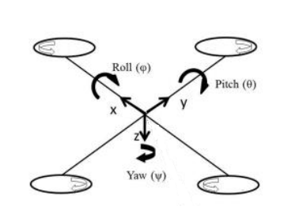
Figure 2: Euler angle representation for quadcopter [12]
For a quadcopter, the roll and pitch angles are called attitudes, the yaw angle is called heading and the vertical distance from the ground (z-axis) is termed as the altitude.
The quadcopter is an under-actuated system, which means that it has a lower number of actuators as compared to its Degrees of Freedom, it only allows for direct control over four DOF, rather than 6. These 4 DOF consist of altitude, attitude, and heading. The other 2 DOF can be controlled through 2 of the rotation angles as roll and pitch rotations generate aircraft movement along the Y and X axes, respectively [4].
Most researchers start with a basic dynamic model of the quadcopter, which is derived by taking the net external forces and torques into consideration. These are usually conventional. However, some have incorporated aerodynamic effects [5,6], which vary according to various applications and environments. [3] and [7] make use of both Newton-Euler equations and Euler-Lagrange equations to derive differential equations that represent the dynamics of the quadcopter. Furthermore, the derivations of these equations for a quadrotor model have been well elaborated by Beard in [8], Corke in [9], Sidea in [10], and Bresciani in [11]. Both methods of deriving these dynamical equations are equivalent, thus also producing an equivalent result. Bouabdallah in [7] incorporates various external effects into his model, including thrust force, hub force, drag moment, rolling moment, and ground effect. However, all these studies have focused on the plus-configuration of the quadcopter, as it is easier to explain the flight mechanisms in this configuration. A quadcopter may also be used in a cross-configuration, as depicted in Figure 3.
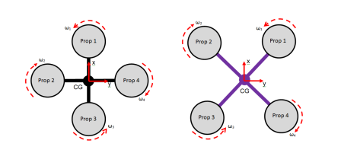
Figure 3: Quadcopter in plus- and cross-configurations [13]
The dynamics regarding thrust and yaw are similar for both, albeit there being different dynamics for roll and pitch.
Defining the reference frames is necessary for deriving quadcopter kinematic equations. Ruth Tesfaye [14], Mehmet Ikulak [15], and Alexander Lebedev [16] use the fact that quadcopter motion is described based on two frames, body frame and inertial frame [17] [18]. However, some researchers like Wei Zhong Fum [13] take the assumption that an additional frame corresponding to quadcopter motion is required, known as the vehicle frame.
Ultimately, the study in [12] puts together all this research to derive the equations for the dynamical model of the quadcopter and creates an adequate model, which they further use to design a controller. They include the effects of the gravitational force, the thrust forces of the propellers, the hub torque acting on the propellers, and the drag force acting due to the non-elliptical shape of the quadcopter, which is an aerodynamic effect. However, other gyroscopic effects like ground effect and gyroscopic effect have been ignored.
- Cascaded Control Loop
After modeling the 6 DOF model of the quadcopter, a cascade control loop is used to linearize the non-linear model. Then linearized equations are used to design a PID-controlled drone in all 6 degrees of freedom. A cascaded control loop architecture is a control strategy that involves the use of multiple PID (Proportional-Integral-Derivative) controllers in a hierarchical or cascaded manner to control a complex system. The goal of cascaded control is to enhance overall control performance and reduce interactions between various control loops. Linearization is beneficial for the drone as it will help the drone maintain a set altitude, enabling it to capture clear images during flight. A common application of cascaded control is to control a primary process variable while using a secondary control loop to manage disturbances or improve the response of the primary loop. The linearization will be performed in Simulink, where linear equations will be used to compare the output of both the linear and non-linear systems. In this architecture, there will be two loops: an inner loop for controlling pitch rate and an outer loop for controlling vertical acceleration.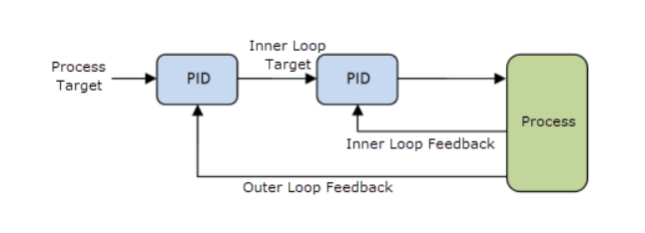
Fig 4. Cascaded Loop Control [19]

The foundations of control theory, on which the PID controller is based, can be traced back to the work of French mathematician Pierre-Simon Laplace in the 18th and 19th centuries. Laplace introduced differential equations and Laplace transforms, which are fundamental tools in control theory [20]. In the 19th century, the concept of the proportional constant, represented by the "P" in PID, was introduced by James Clerk Maxwell. The theoretical basis for integral control, denoted by the "I" in PID, was established by researchers Nicholas Minorsky and Harold Stephen Black in the early 20th century. The "D" in PID, signifying derivative control, was incorporated into control theory by researcher Albert Rea during the early 20th century. In 1911, Elmer Sperry utilized the first-ever PID controller to automate a ship's steering mechanism. Then, in 1914, Laurence Sperry, Elmer Sperry's son, demonstrated the use of a gyroscope and ailerons to enable an aircraft to maintain a level position in the face of disturbances. In 1912, the Foxboro Company achieved a significant milestone in process control by introducing the first on-off controller (binary controller) featuring a calibrated set-point scale. In 1927, Foxboro introduced a pneumatic "narrow band" proportional controller, enhancing the precision and control capabilities of industrial processes [21]. Pneumatic control systems utilize air pressure to regulate various aspects of industrial processes. In 1922, Nicolas Minorsky implemented the PID control architecture to automate ship steering [22]. This work laid the foundation for the application of PID control not only in ship steering but also in the control of various dynamic systems. In 2008, the Department of Computer and Electrical Engineering at the Missouri University of Science and Technology conducted research on a PID-controlled drone that used cascaded loop control to enhance pitch control effectiveness and reduce pitch response lag by adjusting the integral and derivative gains of the pitch PID loop [23].
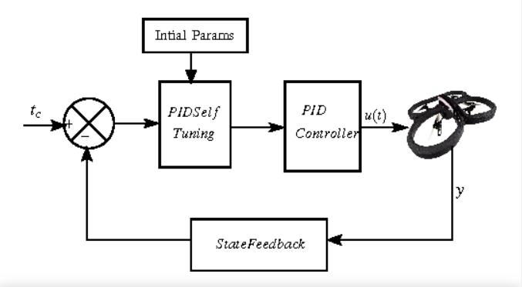
Fig 5. General PID loop for Drones

A group of bachelor’s students from the Department of Computer and Electrical Engineering at the University of Khartoum designed a cascaded loop control architecture for an effective autonomous PID-controlled flight of a drone. Results of implementing the cascaded loop control system can be seen in the figure 6 [24].

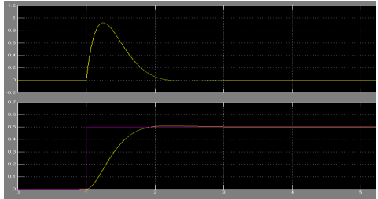
Fig 6. Altitude velocity and Position response after linearization
- Object Detection in RGB Images
Object detection in real-time scenarios, particularly in the context of unmanned aerial vehicles (UAVs), has gained substantial attention in recent years due to its potential applications in surveillance, monitoring, and autonomous navigation. A comprehensive analysis of the current state-of-the-art methodologies for object detection in RGB images, with a specific focus on the integration of the YOLO (You Only Look Once) algorithm and the OpenCV (Open-Source Computer Vision Library) for real-time applications on autonomous UAVs, is discussed below. The review will encompass pre-processing and post-processing techniques to understand the complete pipeline for efficient object detection. The problem of 2D object detection from images is as old as computer vision. It is very important to note that there is no universal agreement in literature on terms such as detection, localization, recognition, classification, categorization, verification, identification, annotation, labeling, and understanding, which are often defined in different ways [25].
• Object detection means to determine whether there are any instances of objects from given categories in an image and, if yes, to return the spatial location and extent for each object instance.
• Object classification and object categorization refer instead to the problem of finding the presence of objects in the image from a given set of object classes, without any localization.
• Object recognition is the problem of identifying and localizing all the objects present in an image [26], thus encompassing both image classification as well as object detection [27].
3.1 Pre-Processing Techniques
• Image Enhancement and Filtering [28]: Various image enhancement techniques, such as contrast adjustment and histogram equalization, have been used to improve the quality of input images. Researchers like Jain et al. (2017) and Zhang et al. (2019) have emphasized the significance of these techniques in enhancing the accuracy of subsequent object detection algorithms.
• Image Registration and Stabilization [28]: Image registration techniques, including feature-based and intensity-based methods, have been employed to align images and compensate for UAV motion. Studies by Li et al. (2020) and Wang et al. (2021) have highlighted the importance of image registration in ensuring consistent input for real-time object detection algorithms.
• Feature Extraction and Augmentation [28]: Feature extraction techniques, including SIFT and SURF, have been utilized to extract robust features for improved object detection. Researchers such as Lowe (2004) and Bay et al. (2008) have extensively discussed the effectiveness of these feature extraction methods in the context of UAV-based object detection.
3.2 Review of Object Detectors
A computer cannot make sense of images, yet it can perform seemingly intelligent tasks like identifying and tracking objects in a video. Object detection algorithms achieve this by sectioning the image and performing classification and localization operations on it. Computers can pass labelled image data for several classes of objects through a neural network and make it constantly adjust its weights and biases at the nodes until the error in the predictions with respect to the labelled input is minimized. After training the neural network in this manner, it can predict different classes of objects in any new image input into it.
To localize an object within an image, the image is divided into rectangular segments represented by bounding boxes, and these are fed through the same classifier network which returns a confidence score for that image segment containing a particular object. The network outputs multiple predictions which are then filtered using algorithms like non-maximum suppression. The result is a single remaining bounding box which is most likely to contain the object of interest. Object detectors can be broadly classified into traditional detectors and deep learning-based detectors (Fig.1).
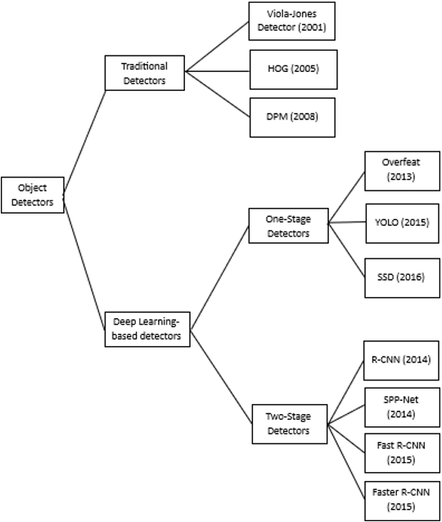
Fig 7. Classification of Object Detectors
Early object detection algorithms were based on a handcrafted features extraction phase upstream, searching for sophisticated feature representations that capture the gist of the image. In those years, a variety of tune-ups to improve accuracy, obtaining invariance with respect to various geometrical and spectral factors, and (near) real-time performance were proposed in the literature, reaching a plateau after 2010 [62]. In 2012, the seminal work of Krizhevsky et al. [29] gave way to the rebirth of Convolutional Neural Networks (CNNs) for image classification tasks. AlexNet (2012) consists of 5 convolutional layers and 3 fully connected layers. Two Graphics Processing Units (GPUs) were used, running different layers of the network and communication only at certain layers. The paper introduced modern concepts such as data augmentation, training on multiple GPUs, Rectified Linear Unit (ReLu) as activation function, max-pooling layers to achieve down sampling, drop-out as a way to perform regularization, achieving a top-5 error of 15.3% on ImageNet Large Scale Visual Recognition Challenge [30]. From that moment, different architectures have been proposed to improve the accuracy of such a task [31]. Here, we report works which represent a milestone achievement or those which will be recurrently named in the manuscript:
• R-CNN [32] (2014) is a two-stage object detector that introduced the search for possible object locations (region proposals) in the image using a selective search; for each proposal, the features were extracted separately by the network, at the cost of high computational load.
• Faster R-CNN [33] (2015) increased speed of R-CNN taking the entire image as input instead of using a CNN for each region proposals introducing RoI pooling layers, improving both accuracy and speed.
• Mask R-CNN [34] (2017) extended Faster R-CNN, adding a branch for also predicting the object mask in parallel with the bounding box recognition.
• YOLO [35] (2016) is a one-step object detector that drastically improves computing speed. Like Faster R-CNN, YOLO uses a single feature map to detect objects, but the image is divided into a grid where J. Imaging 2020, 6, 78 9 of 38 the objects are searched. It was proposed by Joseph Redmon in 2015. It performs feature extraction from the input image using the CNN-based architecture called Darknet as its backbone. The entire input image is divided into several grid cells, and bounding boxes are generated for detection in every grid cell. As a result, multiple bounding boxes are generated, and each has an associated class probability. To deal with objects of different sizes, YOLO uses anchor boxes, which are predefined reference templates of different sizes and aspect ratios for bounding box generation. After all the bounding boxes are generated, YOLO uses the technique of non-maximum suppression to only keep those detections that have a higher probability than a certain threshold value, and the rest are removed. The YOLO algorithm became increasingly popular due to its simplicity and applicability in real-time scenarios. Hence, in subsequent years, its pioneers introduced many improved versions, and newer versions are still being introduced. These include YOLOv1, YOLOv2, and so on. Each of these comes in architectures of variable sizes having different numbers of trainable parameters. The lighter versions with fewer trainable parameters are more suitable for faster, real-time applications, even though they are a little less accurate. The YOLO algorithms still struggle to show the same performance for detecting small and crowded objects as they did for detecting larger objects captured from a clearer point of view.
3.3 Aerial Datasets
The datasets for aerial object detection and tracking are typically acquired by low-altitude drones. The parameters in these datasets can vary greatly based on the types of sensors used for the collection of data. Moreover, the number and position of targets, capturing angle, and altitude can all change drastically across the frames of a video. The UAV123[27], ALOV300++ [36], Temple Color 128[37] and VisDrone[38] are some popular aerial datasets. These are very diverse datasets comprising a wide variety of objects from urban and wildlife environments. Table 1 below shows some of these datasets and the number of elements they contain.
Table 1. Common Aerial Video Datasets
Name of Dataset | Number of images or videos
VOT2017[31] | 60 (21,000 frames)
VisDrone2019[30] | 288 (261,908 frames)
UAV20L [32] | 20 (58,670 frames)
UAV123[27] | 120 (112,578 frames)
Temple Color 128[29] | 129 (55,346 frames)
ALOV300++[28] | 314 (151,657 frames)

- Hardware
Choosing the right hardware for the right application is one of the most crucial parts of the development of any product because these factors affect the dynamics of any mobile platform such as UAV.
4.1 Frame
When choosing the frame for a quadcopter, the following factors are kept in mind to get the best frame according to the requirements [39]:
- Size: The size of the quadcopter is determined by the size of the frame. The frame must be of size enough to house all necessary components, including motors, propellers, battery, and flying controller [39].
- Weight: The overall weight of the quadcopter will be affected by the weight of the frame. A heavier frame will make flying the quadcopter more difficult [39].
- Material: The frame can be composed of several materials, including carbon fiber, aluminum, or plastic. The lightest and strongest material is carbon fiber, but it is also the most expensive. Aluminum has a good weight-to-strength ratio material. Plastic is the cheapest material, but it is also the heaviest and most brittle [39].
- Price: The cost of the frame will depend on its size, weight, and material. Before shopping for the frame, a budget should be constructed [39].
We have chosen an F450 quadrotor frame that is a 450mm frame when measured between opposite rotors. The F450 frame is large enough to carry all the other components. It weighs about 282g which is not too heavy a frame, thus making it an excellent option. The frame is shown in Figure 1 [39].
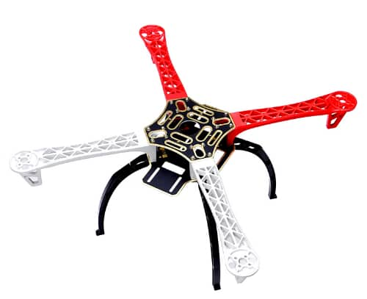
Figure 8. F450 Quadcopter Frame [39]

4.2 Microcontroller
Both the Jetson Nano [40] and the Raspberry Pi 3B [41] are single-board computers capable of object recognition. The Jetson Nano, on the other hand, has some advantages over the Raspberry Pi 3B, making it a better candidate for object recognition applications.
Advantages of Jetson Nano:
- It has a faster GPU, NVIDIA Maxwell [40] than the Raspberry Pi 3B which has the Broadcom VideoCore IV [41]. This improves its performance when executing machine learning and deep learning algorithms for object recognition.
- It has a larger and faster memory with a capacity of 4GB and a speed of 2133MHz [40] than the Raspberry Pi 3B which has 1GB of memory with 900MHz speed [41]. This is significant for object identification applications, which frequently demand a large amount of RAM to hold the machine learning models.
- It consumes less electricity than the Raspberry Pi 3B. This is critical for scenarios where the device will be powered by a battery.
Overall, the Jetson Nano outperforms the Raspberry Pi 3B in object recognition applications due to its more powerful GPU, larger RAM, and lower power consumption.
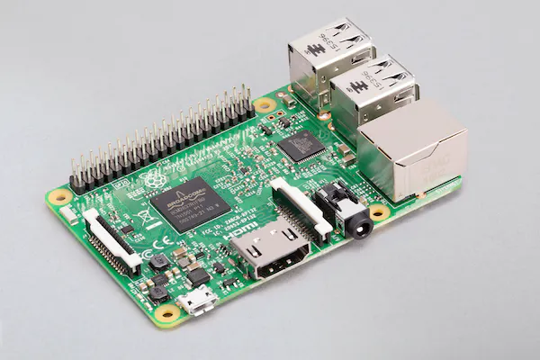
Figure 9. Image of Raspberry pi 3B [41]
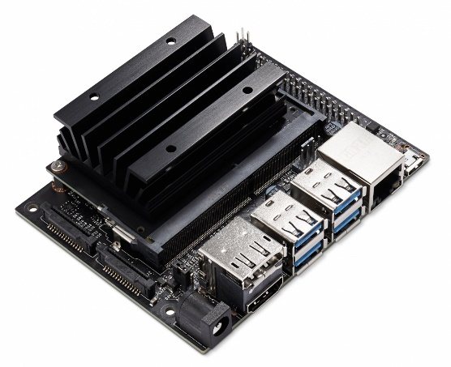
Figure 10. Image of Jetson Nano [40]
4.3 Flight Controller
Pixhawk is a popular open-source autopilot system used in drones and other unmanned aerial vehicles (UAVs). It has a triple-redundant flight controller, a GPS receiver, an inertial measurement unit (IMU), and a magnetometer. Pixhawk is also compatible with a diverse set of sensors and actuators, making it an adaptable platform for a wide range of UAV applications. [42]
Here are a few reasons why Pixhawk is an excellent choice for autopilot applications:
- Opensource: Pixhawk is a free and open-source hardware and software platform. This means that anyone can help create it and that there is a wide community of users and developers who can help. [43]
- Full-featured: Pixhawk is a full-featured autopilot system that comes with everything you need to operate a UAV autonomously. A flight controller, GPS receiver, IMU, and magnetometer are all included. [43]
- Versatile: Pixhawk is compatible with a wide variety of sensors and actuators. As a result, it is a versatile platform for a wide range of UAV applications, including quadcopters, hexacopters, and octocopters. [43]
- Reliable: Pixhawk is a dependable and well-proven autopilot system. It is employed in a variety of UAV applications, including commercial, military, and research. [43]
Pixhawk's position and velocity are provided by the GPS receiver. Its orientation and acceleration are provided by the IMU. Pixhawk gets its heading from the magnetometer. Pixhawk estimates its state using data from the GPS receiver, IMU, and magnetometer. This includes its position, velocity, orientation, and acceleration. Then it utilizes its estimated state to operate the UAV's motors and actuators, allowing it to fly to its goal.
Pixhawk is a sophisticated and adaptable autopilot system that is suitable for a wide range of UAV applications. It is open source, full-featured, dependable, and works with a variety of sensors and actuators. It is also compatible with Ardupilot which is an open-source and reliable platform for developers who want to autopilot their drones. [44]

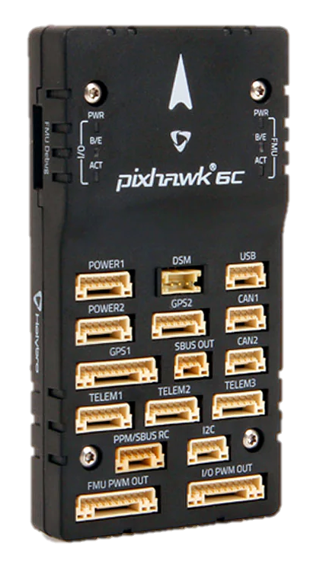
Figure 11. Pixhawk 6c [45]
4.4 RGBD Camera
For object detection, three camera sensor options were available, the Etron stereo camera [46], Microsoft Kinect [47], and Xtion Pro Live RGB motion sensor [48] all of which are excellent sensors. The Xtion Pro Live RGB motion sensor, however, has several advantages over the other two sensors.
The following are the advantages of the Xtion Pro Live RGB motion sensor:
- It is more detailed than the other two sensors. This implies that it can capture more information in its photographs and videos [48].
- It covers a larger area than the other two sensors. This implies it can observe a bigger region at the same time. [48]
- It can record in-depth information in addition to RGB data. This means that it is capable of producing 3D photos and videos. [48]
Because of these benefits, the Xtion Pro Live RGB motion sensor is a better option for object detection than the other two sensors. It can capture more detail and see a bigger area simultaneously due to its better resolution and broader field of view. This facilitates the identification of items using object recognition software. The ability to capture depth information helps the object identification software to generate a 3D representation of the object, which can increase object recognition accuracy.

Table 2 Comparison of Etron, Kinect & Xtion Pro Live [46] [47] [48]
Feature | Etron stereo camera | Microsoft Kinect | Xtion Pro Live RGB motion sensor
Resolution | 1280x720 | 1024x768 | 1920x1080
Field of view | 60° | 57° | 70°
Depth information | No | No | Yes

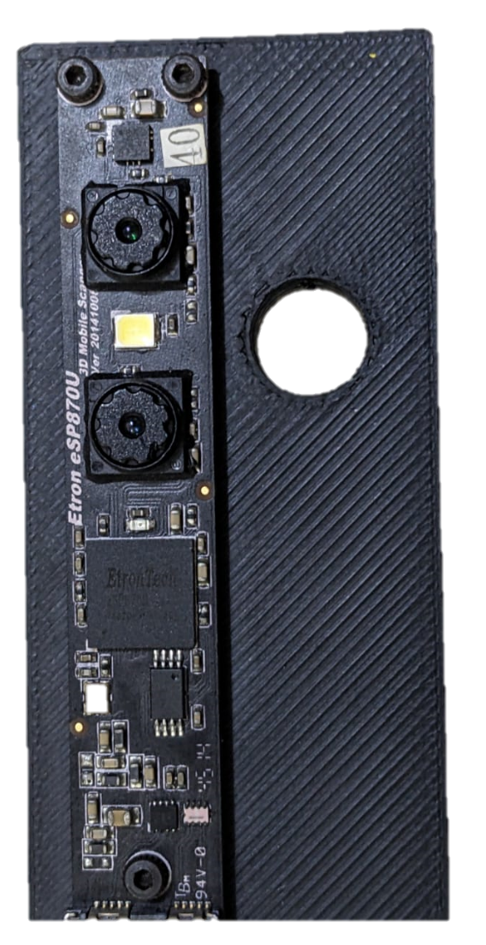
Figure 12. Etron ESP870U

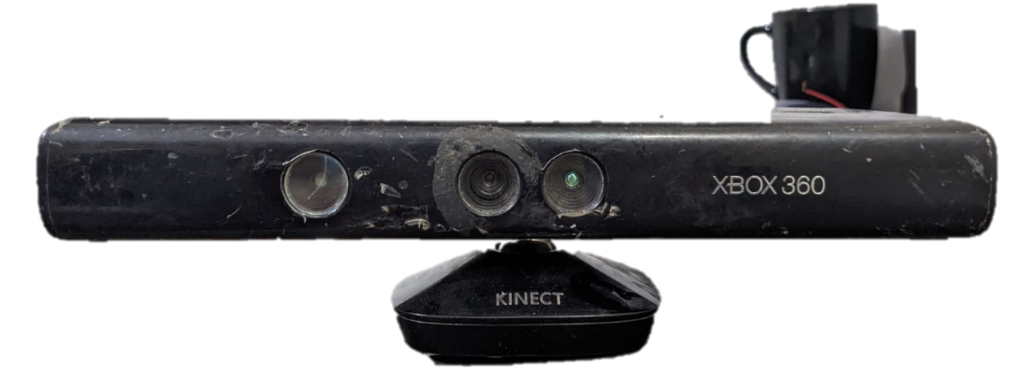
Figure 13. Microsoft Kinect XBOX 360

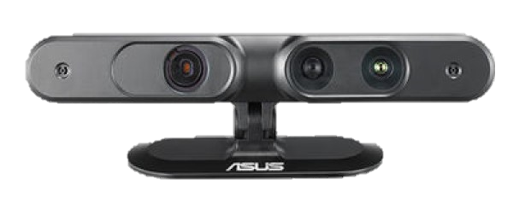
Figure 14. ASUS Xtion Pro Live Motion Sensor [48]
4.5 Actuators
5010-650KV BLDC Motors can operate over the range 11.1V to 22.2V and can take from 10A to 40A. They can produce a thrust of 1000g-4000g. For a 4S LiPo battery which will be discussed later, it can produce 11,100 RPMs [49]. It has a weight of 140g which can be considered a little bit heavy. Because they are powerful and efficient, these motors are ideal for quadcopters. They can generate a lot of thrust, which is necessary for lifting the quadcopter and its payload. They are also efficient, meaning they can create the same amount of thrust with less battery power.
The following are some of the advantages of using 5010-750KV BLDC motors in the quadcopter:
- Power: These motors are quite powerful and can generate a significant amount of thrust. This is necessary for lifting the quadcopter and its payload [49].
- Efficiency: These motors are also incredibly efficient, which means they can create the same amount of thrust with less battery power [49].
- Durability: These motors are extremely tough and can withstand a great deal of abuse. This is especially crucial for quadcopters, which can experience much stress and vibration [49].

Though these motors are very good, they can have some disadvantages as well, such as:
- Cost: The cost of these motors is higher than that of other types of motors [49].
- Weight: These motors weigh more than other types of motors [49].
- Noise: These motors can be very loud [49].
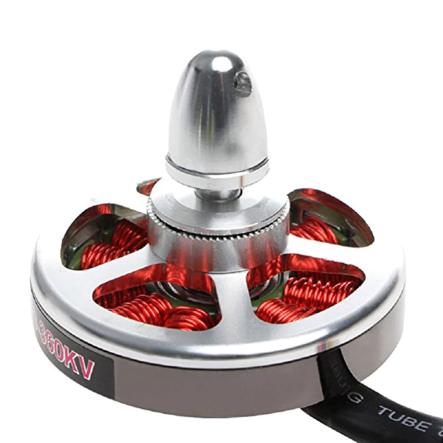
Figure 15. 5010-750KV BLDC Motors [49]
4.6 Electronic Speed Controller (ESC)
Readytosky SIMONK30A ESCs are an excellent choice for controlling the speed of 5010-750KV BLDC motors [50]. They are compact, light, and simple to use. They also have certain characteristics that make them perfect for quadcopter applications, such as:
- High refresh rate: SIMONK30A ESCs have a high refresh rate, which means they can react quickly to changes in the throttle signal. This is critical for quadcopters, which must respond swiftly to pilot input to maintain stability [50].
- Linear BEC: SIMONK30A ESCs contain a linear BEC, which means they can give a consistent voltage to the receiver and other electronics even when they are under load. This is critical for quadcopters, which require a stable power source to operate securely [50].
- Low voltage cutoff: SIMONK30A ESCs have a low voltage cutoff, which means they will automatically turn off the motors if the battery voltage falls too low. This is a vital safety feature that can prevent battery and motor damage [50].
To use SIMONK30A ESCs to control the speed of 5010-750KV BLDC motors, ESCs are connected to the motors and the receiver. ESCs must be calibrated according to the motors.
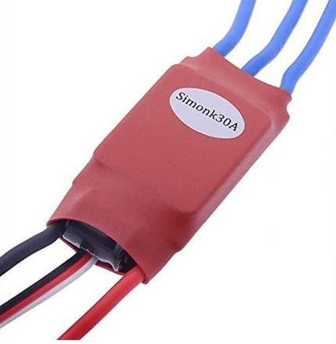
Figure 16. SIMONK30A ESC [50]
4.7 Lithium Polymer (LiPo) Battery
The CNHL G+ 5000mAh 4S 70C LiPo battery is a high-performance battery suitable for a wide range of applications such as quadcopters, helicopters, and airplanes [51]. It has a high discharge rate of 70C, which means it can supply a lot of power to motors even when they are under severe load. It also has a large capacity of 5000mAh, allowing it to power long flights or races [51].
The following are some of the advantages of using a CNHL G+ Plus 5000mAh 4S 70C LiPo battery:
- High discharge rate: The battery's high discharge rate of 70C means it can give a lot of power to the motors even while under heavy load. This is critical for quadcopters, helicopters, and airplanes, which require a great deal of power to fly.
- Long capacity: The battery's 5000mAh capacity implies that it can power long flights or races. This is critical for quadcopters and airplanes that can fly for extended periods of time.
- High quality: CNHL G+ Plus batteries are constructed with high-quality components. This implies they are long-lasting and can tolerate a lot of wear and abuse.
Here are some of the specifications of the CNHL G+ Plus 5000mAh 4S 70C LiPo battery [51]:
- Capacity: 5000mAh
- Voltage: 14.8V
- Discharge rate: 70C
- Weight: 515g
- Dimensions: 38x50x145mm

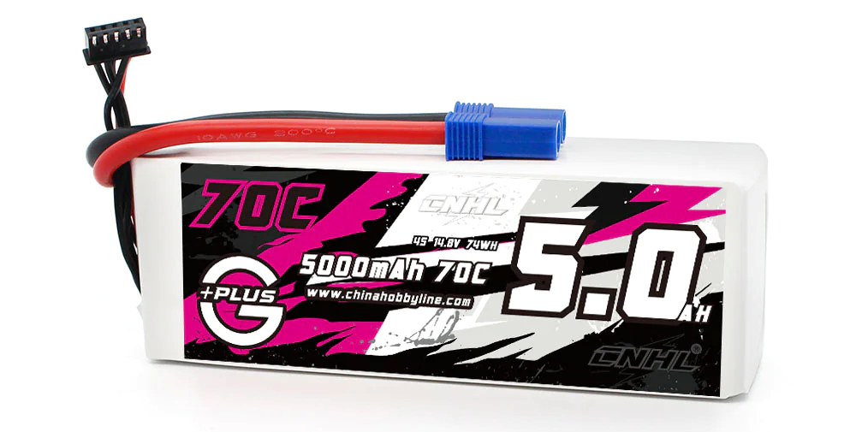
Figure 17. CNHL G+ 70C 5000mAh Battery [51]
4.8 Propeller
The right propellers are crucial for the required thrust produced by the motors. The following factors can help while selecting propellers:
- Size: The size of the propeller will affect the thrust and efficiency of the quadcopter. Choosing propellers that are the right size for the quadcopter's motors and frame is essential. [52]
- Pitch: The pitch of the propeller will affect the speed and thrust of the quadcopter. A higher-pitch propeller will provide more thrust, but it will also be less efficient. A lower-pitch propeller will be more efficient, but it will also provide less thrust [52].
- Material: Propellers are made from a variety of materials, such as plastic, wood, and carbon fiber. Carbon fiber propellers are the most expensive, but they are also the lightest and strongest [52].
We have selected 9.5in carbon fiber propellers because they are durable, efficient, have great responsiveness, and are very quiet making them a good option to use for the quadcopter.

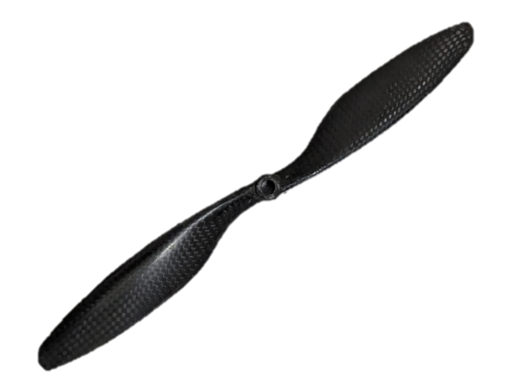
Figure 18. Carbon Fiber Propeller
5. Conclusion
In contrast to prior efforts of designing a controller for a 6 DOF quadcopter which only considered hub torque, thrust force, drag force, and gravitational force effects in the dynamic model of their quadcopter, our work also incorporates the consideration of gyroscopic and ground effects as these two effects were not previously considered by any other group for developing 6 DOF model and simulation. This broader approach promises a smoother and more effective PID-controlled drone flight. Based on historical precedents, it is apparent that no one has undertaken a similar endeavor to the one we propose that involves starting with the designing of 6 DOF simulation of a drone on SIMULINK, then designing the cascaded loop control system, followed by installing a camera to capture some images, along with an on-board processor and finally implementing the concepts of machine learning to train a model using those images. While some groups have explored components of our project, none have encompassed the entirety of these elements.

References
[1] Benavidez, J., J. Lambert, J. Aldo, & M. Jamshidi, Landing of a quadcopter on a mobile base using fuzzy logic, advance trends in soft computing. Studies in Fuzziness and Soft Computing, 312, 429-437, 2014.
[2] Escamilla, R., Diseño, construcción, instrumentación y control de un vehículo aéreo no tripulado. Tesis de Ingeniería, Escuela Superior de Mecánica y Eléctrica, Instituto Politécnico Nacional. México D.F, 2010
[3] Luukkonen, T. (2011). Modelling and control of quadcopter. Independent research project in applied mathematics, Espoo, 22(22).
[4] Kurak, S., & Hodzic, M., Control and estimation of a quadcopter dynamical model. Periodicals of Engineering and Natural Sciences, 6(1), 2018, pp. 63-75.
[5] G. M. Hoffmann, H. Huang, S. L. Waslander, and C. J. Tomlin, “Quadrotor helicopter flight dynamics and control: Theory and experiment,” Proceedings of the AIAA Guidance, Navigation and Control Conference and Exhibit, Aug. 2007.
[6] H. Huang, G. M. Hoffmann, S. L. Waslander, and C. J. Tomlin, “Aerodynamics and control of autonomous quadrotor helicopters in aggressive maneuvering,” IEEE International Conference on Robotics and Automation, May 2009, pp. 3277–3282.
[7] S. Bouabdallah, “Design and control of quadrotors with application to autonomous flying,” M.S. thesis, Dept. Sci and Eng., EPFL, Lausanne, Switzerland, 2007.
[8] W. R. Beard. (2008, Oct. 3). Quadrotor dynamics and control. [Online]. Available: http://rwbclasses.groups.et.byu.net/lib/exe /fetch.php?media=quadrotor:beardsquadrotornotes.pdf
[9] P. Corke, Robotics, Vision and Control. Berlin: Springer, 2013, pp. 79–90.
[10] A. G. Sidea, R. Y. Brogaard, N. A. Andersen and O. Ravn, “General model and control of an n rotor helicopter,” in J. Phys.: Conf., Series 570, 2014. pp. 052004.
[11] T. Bresciani, “Modelling, identification and control of a quadrotor helicopter,” M.S. thesis, Dept. Automatic Control, Lund Univ., Lund, Sweden, 2008
[12] Hussein, A., & Abdallah, R., Autopilot Design for a Quadcopter. Khartoum: University Of Khartoum, 2017
[13] Fum, Wei Zhong, Implementation of Simulink controller design on Iris+ quadrotor, Naval Postgraduate School, Monterey, California, 2015.
[14] Ruth Tesfaye (2012). Modeling and Control of a Quad-rotor Unmanned Aerial Vehicle at Hovering Position. Addis Ababa university, School of graduate studies, Addis Ababa Institute of technology, Electrical and computer engineering department, 2012
[15] Mehmet S. BÜYÜKSARIKULAK, Autopilot design for a quadcopter, The graduate school of natural and applied science of Middle East technical university, 2014.
[16] Alexander Lebedev, Design and Implementation of a 6DOF Control System for an Autonomous Quadrocopter, Julius Maximilian University of Würzburg, Faculty of Mathematics and Computer Science, 2013
[17] Heba talla M. N. ElKholy (2014), Dynamic Modeling and Control of a Quadrotor Using Linear and Nonlinear Approaches. American university in Cairo, School of Science and Engineering, 2014 .
[18] C Balas, Modelling and Linear Control of a Quadrotor, Cranfield University, 2007.
[19] “Cascade Control”, Delta motion https://deltamotion.com/support/webhelp/rmctools/Controller_Features/Control_Modes/Advanced_Control/Cascaded_Loops.htm
[20] “Pierre-Simon Laplace”, Wikipedia, https://en.wikipedia.org/wiki/Pierre-Simon_Laplace
[21] Aidan. O’Dwyer, “PID control: the early years”. Control in the IT Sector Seminar, Technological University of Dublin, January 2005.
[22] S.Bennet, “Nicolas Minorsky and the Automatic Steering of Ships”, UNIVERSIDADE FEDERAL DE MINAS GERAIS, April 2009.
[23] David Erdos and Steve Eugene Watkins, “UAV Autopilot Integration and Testing”, Missouri University of Science and Technology, April 2008.
[24] Amir Nasir Babiker Hussein, “AUTOPILOT DESIGN FOR A QUADCOPTER”, University of Khartoum, October 2017.
[25] Andreopoulos, A.; Tsotsos, J.K. 50 years of object recognition: Directions forward. Comput. Vis. Image Underst. 2013, 117, 827–891.
[26] Ponce, J.; Hebert, M.; Schmid, C.; Zisserman, A. Toward Category-Level Object Recognition; Springer: Cham, Switzerland, 2007; Volume 4170.
[27] Russakovsky, O.; Deng, J.; Su, H.; Krause, J.; Satheesh, S.; Ma, S.; Huang, Z.; Karpathy, A.; Khosla, A.; Bernstein, M.; et al. Imagenet large scale visual recognition challenge. Int. J. Comput. Vis. 2015, 115, 211–252.
[28] K. Jain, Fundamentals of Digital Image Processing. Englewood Cliffs, NJ: Prentice Hall, 1989
[29] Krizhevsky, A.; Sutskever, I.; Hinton, G.E. Imagenet classification with deep convolutional neural networks. In Advances in Neural Information Processing Systems; Neural Information Processing Systems Foundation, Inc.: San Diego, CA, USA, 2012; pp. 1097–1105
[30] Deng, J.; Dong, W.; Socher, R.; Li, L.J.; Li, K.; Fei-Fei, L. Imagenet: A large-scale hierarchical image database. In Proceedings of the 2009 IEEE Conference on Computer Vision and Pattern Recognition, Miami, FL, USA, 20–25 June 2009; pp. 248–255.
[31] Zou, Z.; Shi, Z.; Guo, Y.; Ye, J. Object detection in 20 years: A survey. arXiv 2019, arXiv:1905.05055
[32] Girshick, R.; Donahue, J.; Darrell, T.; Malik, J. Rich feature hierarchies for accurate object detection and semantic segmentation. In Proceedings of the IEEE Conference on Computer Vision and Pattern Recognition, Columbus, OH, USA, 24–27 June 2014; pp. 580–587
[33] Ren, S.; He, K.; Girshick, R.; Sun, J. Faster r-cnn: Towards real-time object detection with region proposal networks. In Advances in Neural Information Processing Systems; Neural Information Processing Systems Foundation, Inc.: San Diego, CA, USA, 2015; pp. 91–99
[34] He, K.; Gkioxari, G.; Dollár, P.; Girshick, R. Mask r-cnn. In Proceedings of the IEEE International Conference on Computer Vision, Venice, Italy, 22–29 October 2017; pp. 2961–2969
[35] J. Redmon, S. Divvala, R. Girshick, and A. Farhadi, “You Only Look Once: Unified, Real-Time Object Detection,” Proc. IEEE Comput. Soc. Conf. Comput. Vis. Pattern Recognit., vol. 2016-December, pp. 779–788, Jun. 2015, doi: 10.48550/arxiv.1506.02640.
[36] “www.alov300pp.joomlafree.it.” http://alov300pp.joomlafree.it/component/dsmanager/?task=showcategory&cid=1
[37] “Temple Color 128.” https://www3.cs.stonybrook.edu/~hling/data/TColor-128/TColor-128.html
[38] “VISDRONE.” http://aiskyeye.com/
[39] | Mathaelectronics, [Online]. Available: https://www.mathaelectronics.com/product/f450-quadcopter-frame/.
[40] | NVIDIA, "Jetson Nano Developer kit," [Online]. Available: https://developer.nvidia.com/embedded/jetson-nano-developer-kit.
[41] | R. Pi, "Raspberry Pi 3 Model B," [Online]. Available: https://www.raspberrypi.com/products/raspberry-pi-3-model-b/.
[42] | Pixhawk, "Pixhawk," Pixhawk, [Online]. Available: https://pixhawk.org/.
[43] | PX4, "Open Source Autopilot for Drone Developer," [Online]. Available: https://px4.io/.
[44] | Ardupilot, "Ardupilot," [Online]. Available: https://ardupilot.org/. [Accessed 01 10 2023].
[45] | Pixhawk, "Pixhawk 6C," Holybro, [Online]. Available: https://holybro.com/products/pixhawk-6c. [Accessed 39 10 2023].
[46] | Etron, "3d Sensing Modules," Etron Technology, Inc., [Online]. Available: https://etron.com/news_list/etrons-3d-stereo-camera-and-depth-map-controller-ic-esp870-wins-computex-2014-best-choice-golden-award/. [Accessed 30 10 2023].
[47] | M. Ignite, "Kinect for Windows," Microsoft, [Online]. Available: https://learn.microsoft.com/en-us/windows/apps/design/devices/kinect-for-windows. [Accessed 30 10 2023].
[48] | ASUS, "XTION PRO LIVE," ASUS, [Online]. Available: http://xtionprolive.com/asus-xtion-pro-live. [Accessed 30 10 2023].
[49] | H. Hobby, "5010 750KV HIGH TORQUE BRUSHLESS MOTOR FOR DRONE," I-ROTOR, [Online]. Available: https://www.havochobby.com/products/5010-750kv-high-torque-brushless-motor-for-drone. [Accessed 30 10 2023].
[50] | UDVABONY, "UDVABONY," Readytosky, [Online]. Available: https://udvabony.com/product/hobbypower-simonk-30a-esc/. [Accessed 30 10 2023].
[51] | CNHL, "CNHL G+Plus 5000mAh 14.8V 4S 70C Lipo Battery with EC5 Plug," CNHL, [Online]. Available: https://chinahobbyline.com/products/cnhl-gplus-series-5000mah-14-8v-4s-70c-lipo-battery-with-ec5-plug. [Accessed 30 10 2023].
[52] | projectgo, "9 BEST Drone Propeller Replacements for Your UAV Drone," [Online]. Available: https://projectgo.pro/drone-propeller/. [Accessed 30 10 2023].

